# 1. chick [čik]

# 2. duckling [dakliŋ]

**3. ribbon** [ribən]

**4. chocolate eggs** [čoklit egs]

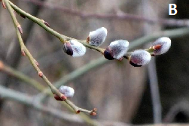**5. basket** [bɑːskit]

# 6. daffodil [dæfədil]

**7. Easter** [iːstə]

# 8. lamb [læm]

# 9. catkins [kætkins]

# 

# 10. bunny [bany]

# 

